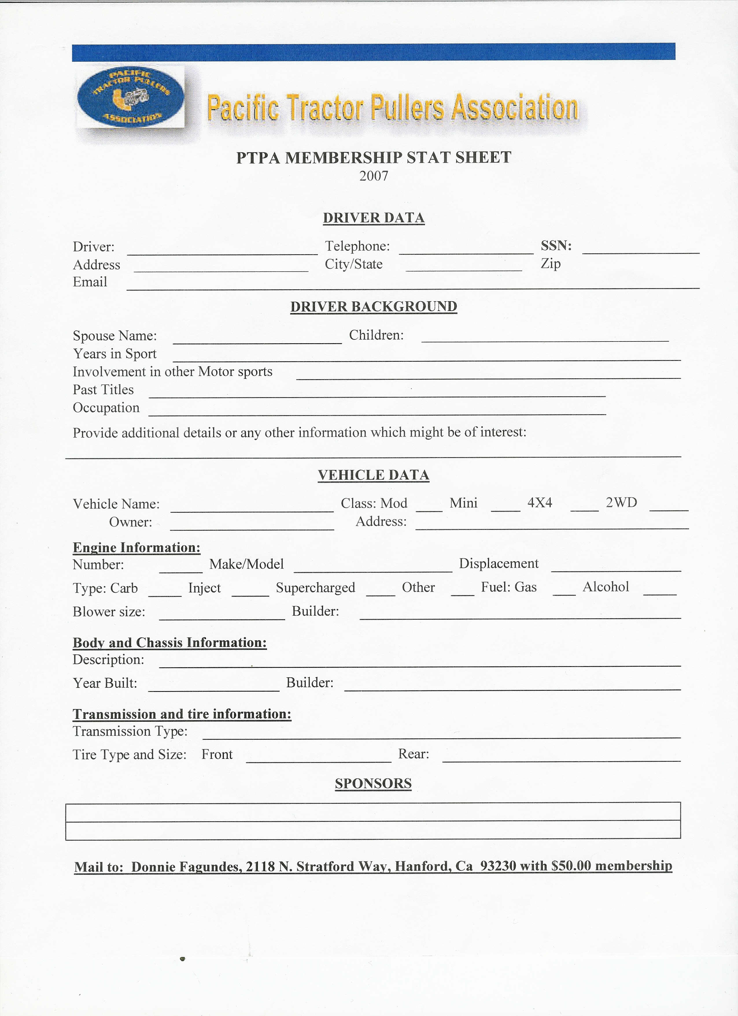

DRIVER DATA

Driver: Cell Number: SSN
Address: City/State Zip
Email:

DRIVER BACKGROUND

Spouse Name: Children:
Years in Sport
Involvement in other Motor Sports:
Past Titles:
Occupation:

Provide additional details or any other information which might be of interest:

VEHICLE DATA

Vehicle Name: Class: Mod Mini ___
Owner: Address:

Engine Information:
Number: Make/Model: Displacement:

Type: Carb ___ Injected _ Supercharged __ Other ____ Fuel: Gas _ _ Alcohol ____
Blower size: Builder:

Body and Chassis Information:
Description:
Year Built: Builder:

Transmission and tire information:
Transmission type:
Tire Type and Size: Front: Rear:

SPONSORS

Checks ($150, before Jan 31, $250 after Feb 1) payable to PTPA, mail to M. Zohns, 75 Guerra Dr. San Luis Obispo, CA 93405

